MS/WT Power Platform Weekly Connect (Rafael)

Wednesday, October 26, 2022

11:59 AM

* + Something breaks on medical side, more catastrophic
    - If it's on corporate side, it's more resolvable, but medical issues interrupt ability to care for patients
    - Is there way to have a flow, maybe app, flow, to allow user to come in and request access for app inside name environment directly frm default env
    - Use trigger, PA flow? That will automatically add them to group
    - Rafael:
      * You want to only lock it down
      * Share it only with group, not with KP
      * Users might not be part of 10000 group, might want to req access
      * Want to host app on default env
      * Why do you want to host on default env if you can host on name? env.
      * What data source being used?
        + Only using Sharepoint
    - Pratik
      * If user wants to use app, do they need to be added to share point list -> No.
    - Second app has self-center
      * Can people just add themselves to the gorup or need approval. What stops normal users from requesting access?
      * Pratik: request itself doesn't need approval
        + If need access, user is added to security group, app is auto shared, and they can begin testing
        + Rafael: can be done, Have app trigger flow with a button

Add user to the group, then share app with group instead of sharing individually with the user

* + - Mrunmay:
      * We don't have list of users, anticipating 10k users, don't have tracking mech, just post app link to sharepoint group?
      * ID everyone who is using it with mechanism that sees everyone who is trying to log into app, put them all into security group
    - Rafael:
      * If you don’t have all in the security group, use gate to chedck if they are in group, if not, add them to the group shared with the app
    - Mrunmay
      * Everyone has access to def env
    - Pratik:
      * If they want to keep track of ppl coming and have access, could write to shraepoint list,
      * User can go to request app, enter email, UUID
        + Backend automation adds them to sec. group and verifies app is shared with group
        + User gets notif that they have access to the app
    - Rafael:
      * Unless want separate sharepoint, this solution is fine
    - Pratik:
      * Users don't usually know where to go in admin center, sharepoint is easier for them to know where to go
      * Need to discuss removing people, restricting users if wanted, missing functionality to restrict users we don't want accessing, since there's no tracking yet
      * Talking with Chris about moving to named env.
      * As long as theyre ready with named env to transfer all the migrations, they won't appoint anyone to that env and keep it in the default
      * Tracking mechanism could keep track of how many ppl are using it
      * Will talk with chris about how to move forward with tracking users
      * Chris's intake is done, rudi needs to approve
    - Mrunmay
      * Was mentioning theyre pulling data to sharepoint, planning to put it here and make it in the def environment
    - Pratik
      * Anyone who gains access isn't necessarily restricted
      * Follow up questions on how to remove ppl, if any restrictions needed within the application (currently none, but needs clarification)
    - Rafael: will be testing and setting up a similar architecture so he can have hands-on build and to be ready for potential issues?
    - Mars Portal Question:
      * Situation came up; someone trying to register for external acc
      * External regis. Is not allowed at KP, supposed to be turned off at portal
      * Misscomm with handoff for developers caused this issue
      * Trying to understand this error:
      * 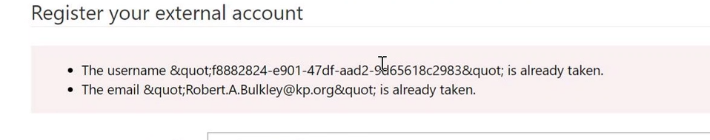
      * Docs said make sure there's unique ID or email, but going in Azure AD showed the record WAS unique (roadblock)
      * Rafale noted that user aadded to env as portal contact so trying to reg. againt causes issue
      * First time registering, assoc. object ID and email of azure AD user, trying to register again says this "already taken"
      * Admin Center > Env > KP Mars > Apps
      * At Custoemr Service Hub > Accs > Contacts
        + Checking robert buckley data in Active Contacts
        + Checking Portal Contact for GUID

Found at Web Authentication > Username

* + - * + This isn't considered a user error
        + This individual went to register but didn't consider if they had already signed in
        + Check with richard? About sys admin of the portal
        + If user intends to sign in and gets "already exists" error ?
      * When someone changes email, bug showed up with using new email creates same existing username
        + Might have to delete the profile and allow them to reregister
    - Rafael: were you looking into setting up working session
    - Mrunmay - needs it to start exploring the to-be added sql tables
      * If data sits in a sql database, it'll write to a virtual table, within the tenant?
      * Start with SQL and then move to sharepoint
    - Rafael: sharepoint would be easier to implement this
      * For a SQL table, need to setup Odata provider to have communication work, will double check if this condition was made easier
      * Once into virtual table conv. Was announced that youd be able to build virtual table from antoher dataverse table in separate env
        + Can still consume the dataverse table from a separate environment, coming soon?
    - Mrunmay noted this is lower priority
    - Backlog item would be to learn more about Virtual tables, KY2023?
      * Backup tables asap
    - Rafael is researching on-premise gateway topic, will have more next week
    - Mrunmay setup intake for friday